

MEMO 2019-02

TO : SALES OFFICE, PLANT 2 & PLANT 1
FROM : MANAGEMENT
RE : REQUEST FOR DRAWING NUMBERS IN so & STOCK ENTRY OF POSTS
DATE : April 10, 2019
____________________________________________________________________________________

Please be informed of the following revised process

- RFD NUMBERS IN SALES ORDER:

All drawing numbers shall be indicated in the space provided when editing the item code per row. Input of drawing numbers in the description is not allowed anymore.
See below picture for your reference.

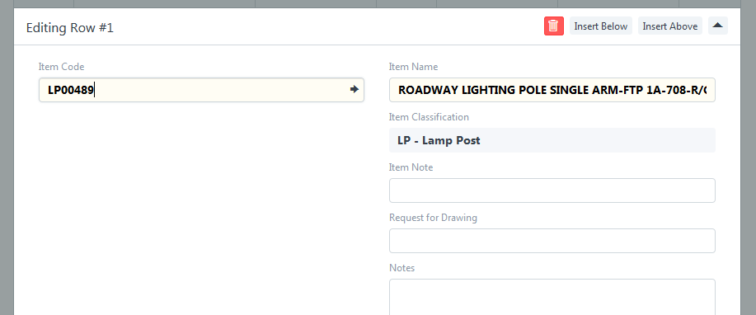

- STOCK ENTRY OF POSTS:

Starting Saturday, April 13, 2019, stock entry of posts will no longer be done by Material Management Personnel. Instead, Engr. Gabriel Ventura and Orlando Reyes of Plant 1 will do the feed-backing.

This is for your guidance and strict compliance.

Noted by:

FREDERICK CHUA
Director for Operations

